Profile Construction procedure for ProtoDUNE- Vertical Drift

Rohit Raut, Eric Garcia, Tyler Strokes, Atharva Dange

[Rohit.raut@uta.edu](mailto:Rohit.raut@uta.edu)

15 Feb 2023

Abstract

This documentation provides a comprehensive guide for constructing four types of profiles - Thick Straight, Thin Straight, Thick Bend, and Thin Bend profiles - that are critical components for maintaining a stable electric field inside the cryostat of the proto-DUNE vertical drift. The document emphasizes the significance of quality checking the profiles for scratches or damages before initiating the construction process. The profiles are then cut to their required lengths based on their designated use and cleaned thoroughly using flat metal files. The drilling process for creating holes in the profiles is also detailed, highlighting the importance of ensuring the smoothness of the holes. The paper outlines the construction process for both straight and bend profiles, with each profile being quality checked before being shipped for mounting. The procedure for constructing bend profiles is described in detail, including the use of a profile bender stop, a Teflon block, and paper towels to ensure the profile is bent smoothly and without any rough surfaces. Finally, the paper highlights the significance of the profiles in the successful construction of the proto-DUNE vertical drift and emphasizes the importance of maintaining consistency in the length of the profiles through the use of a stopper or blocker. By following the step-by-step guide provided in this documentation, the construction of high-quality profiles can be achieved, ensuring the successful operation of the proto-DUNE vertical drift.

Steps Followed

1. Check the profile for scratches or damages. Cut the profiles to the correct length for their usage - thin straight, thick straight, thin bend, and thick bend profile.
2. Clean the profile properly using the flat metal files until properly smooth and rough part can’t be felt.
3. Drill hole in both side of the profile using hydraulic drill and aluminum block.
4. Clean the hole properly for no sharp edges or aluminum is felt.
5. QA/QC profile by running the bare hand to feel if there is any damage in profile.
6. Insert the end caps to the straight profile and is ready to be shipped, or else continue for the bend profile.
7. Clean the section of the profile that will be bent by the Teflon block, and insert the profile bender stop and the Teflon block with bolt.
8. Slide the profile through the Teflon block until it runs into the stop.
9. Place a single layer of paper towel into the clamp block, covering all edges that will touch the profile. Clamp the clamp block onto the profile.
10. Use the thick silver plunger for thin profiles and the gold brass plunger for thick profiles.
11. Remove the profile bender stop.
12. For thin profiles, go ahead and bend. For thick profiles, insert rubber inserts into the profile, and Pull the profile bender handle all the way through in a smooth manner.
13. Grab the clamp block and slide the Teflon block back 60% of the bend. Unclamp the clamp block, making sure to control all movement.
14. Remove the clamp and clamp block and slide the Teflon block off the end of the profile.
15. Feel the inside of the bend. If there are bumps or waves, reject the profile and remember to control all movement and pull the bender smoothly.
16. Place the profile into the QC tool. For thin profiles, use a thicker shim (4mm thicker than thick profiles).
17. If the profile doesn’t fit, it is too long. If the profile fits, but the shim can go in, it is too short.
18. Add end caps to both sides of the profile, leaving one side without rivets and store.

Procedure

The profiles used in the cryostat are extremely delicate and must be handled with great care, as they are responsible for maintaining a stable electric field. Given that 300kV of electric current runs through them, it is critical that the profiles do not have any rough surfaces. There is no fixed quality check procedure for detecting rough edges, so the profile is checked by running a bare hand over it. After the initial quality check is performed, the profile is placed on a construction table and wrapped in plastic to prevent damage during the procedure. Once the QA/QC is complete, the profiles are cut to different lengths using a high-speed cutoff tool. To minimize the amount of aluminum debris, the cutter is run at the lowest possible speed. In order to ensure consistency in profile length, a fixed glass block is used as a stopper. However, during the cutting process, a small amount of aluminum is lost based on the thickness of the cutter (~2mm). The different lengths of profiles that are cut are listed below:

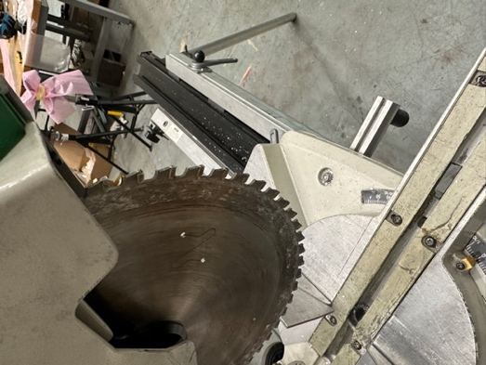

~2mm thickness of the cutter

Fig. Profile in Vertical drift

|  |  |  |
| --- | --- | --- |
| Type of profile | Length cut | Number of profiles required |
| Thick Straight Profile | 2950mm | 84ct |
| Thick Bend Profile | 3623.16mm | 168ct |
| Thin Straight Profile | 2950mm | 144ct |
| Thin Bend Profile | 3616.1 | 288ct |

After the cutting procedure is completed, the profile are properly cleaned using the flat metal plates until the profile is properly smooth, which is tested by running your bare hand through a cleaned section. Everyone is supposed to be very careful while running the hand as any aluminum remaining might result in cutting of your hand.

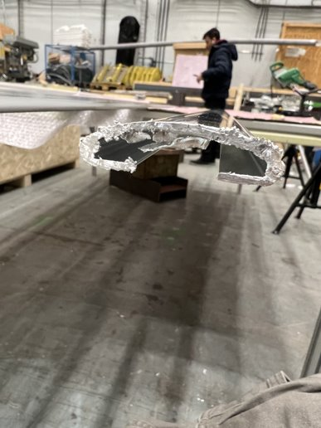

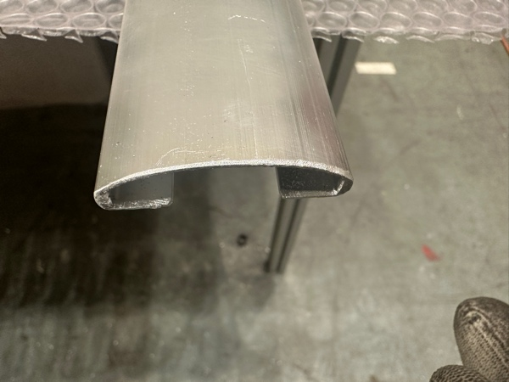

Fig. Before and After the cleaning of the Profile

There should not be any aluminum remaining as it might result in arcing when the high current is passes inside the cryostat. Also, any scratch in the outer part of the profile during cleaning procedure will be resulted in the failure of the quality check of the profile.

The profile is then drilled using the hydraulic drill, and an aluminum block designed to drill hole at specific length in the profile. The different aluminum block is used to drill the hole in thick and thin profile. The holes are cleaned using the similar metal plates to remove any kind of metal debris.

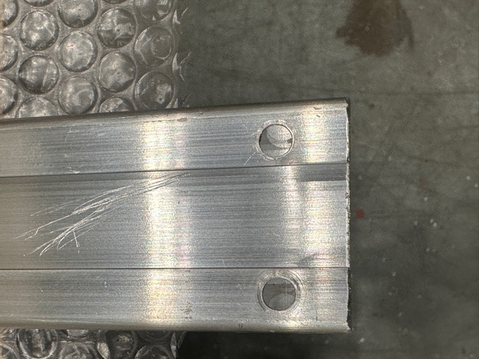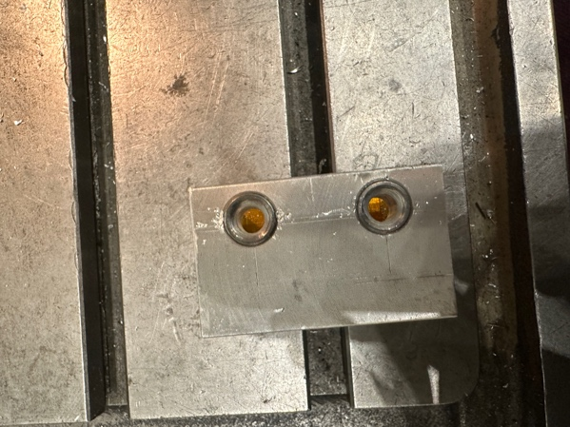

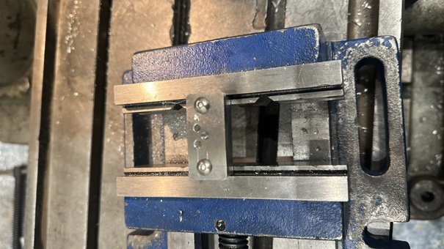

Fig. Aluminum block for drilling & Final Resulting profile after drilled and properly cleaned

The procedure of cutting, cleaning and drilling is similar for all the straight and bend profile. After the drilling and cleaning of the profile is completed, once again the QC of the profile is done by running a bare hand through a profile to check if there is any damage in the profile. Any noticeable scratch or any scratch that can be felt by bare hand in the profile is considered to fails the QC of the profile.

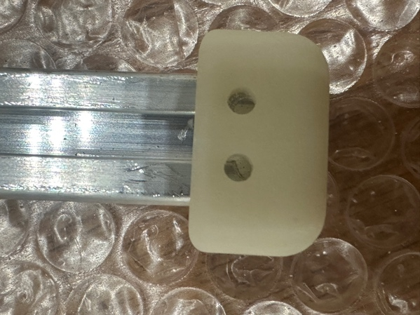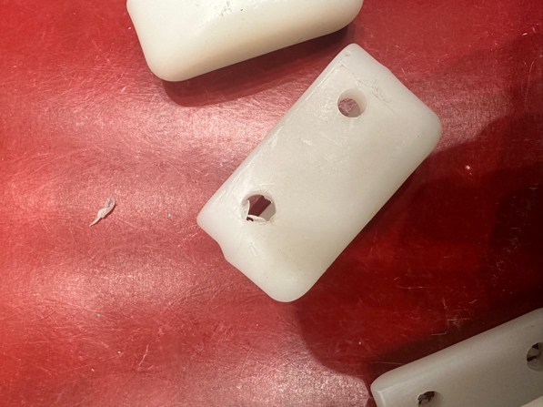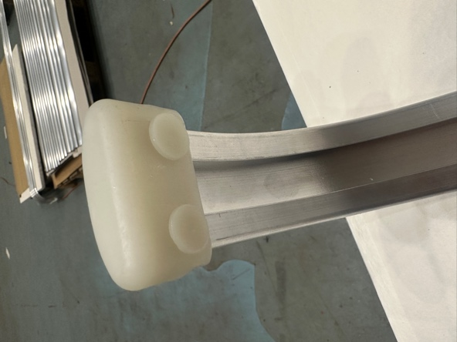After the QC is completed, the end caps are inserted in the profile. End caps are specifically designed to protect the profile from any damage and avoid any sharp edges inside the cryostat. The end caps are properly inserted, and rivets are used in one side of the profile, however the next side of the profile is left open for mounting of the profile.

1. End Caps closed with Rivets. B. End caps without rivets C. Damaged End caps

End caps with any plastic pieces are considered damage and special attention needed to look for inside the endcaps. After the procedure is completed, the straight profile is properly packaged in crate and shipped to sites.

Thick and Thin profile are also needed to be bend and go through a different bending procedure.

To bend an aluminum profile, First insert the profile bender stop and then insert the Teflon block with bolt. Before bending, it is essential to clean the profile, at a minimum, the section that will be bent by the Teflon block. Next, slide the profile through the Teflon block until it runs into the stop. Place a single layer of paper towel into the clamp block, covering all edges that will touch the profile. Then clamp the clamp block onto the profile. If the profile is thin, use the thick silver plunger, and if it is thick, use the gold brass plunger.

Once the clamp block is secured, remove the profile bender stop. For thin profiles, go ahead and bend, but for thick profiles, insert rubber inserts into the profile. Pull the profile bender handle all the way through in a smooth manner. Grab the clamp block and slide the Teflon block back 60% of the bend. Unclamp the clamp block, making sure to control all movement. Remove the clamp and clamp block and slide the Teflon block off the end of the profile.

Feel the inside of the bend to ensure there are no bumps or waves. If there are, reject the profile, and remember to control all movement and pull the bender smoothly. Next, place the profile into the QC tool. For thin profiles, you will need a thicker shim that is 4mm thicker than thick profiles. If the profile doesn't fit, it is too long. If the profile fits, but the shim can go in, it is too short. Finally, add end caps to both sides of the profile, leaving one side without rivets, and store it safely.

Overall Setup for Bending of Profile

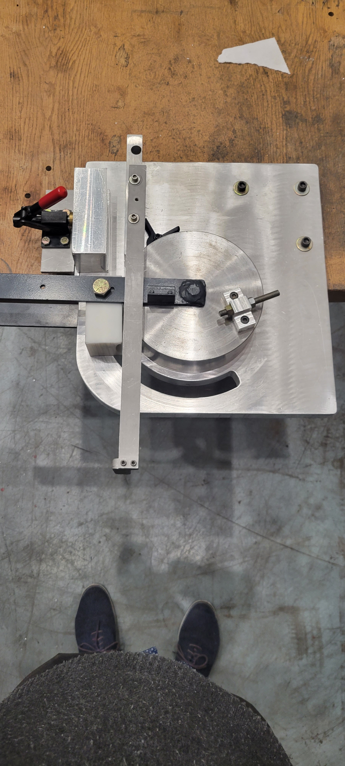

Profile Bender Arm

Profile Length Stop

Cylinder

Teflon Block

Profile Clamp Block

Profile Clamp

Profile Bend Stop

Profile clamp is used to stabilize the profile clamp block to fit perfectly with profile during the bending procedure. There is one profile clamp with interchangeable plunger head.

* Gold color plunger is for thick profiles
* Silver color plunger is for thin profiles

Thin Profile

Thick Profile

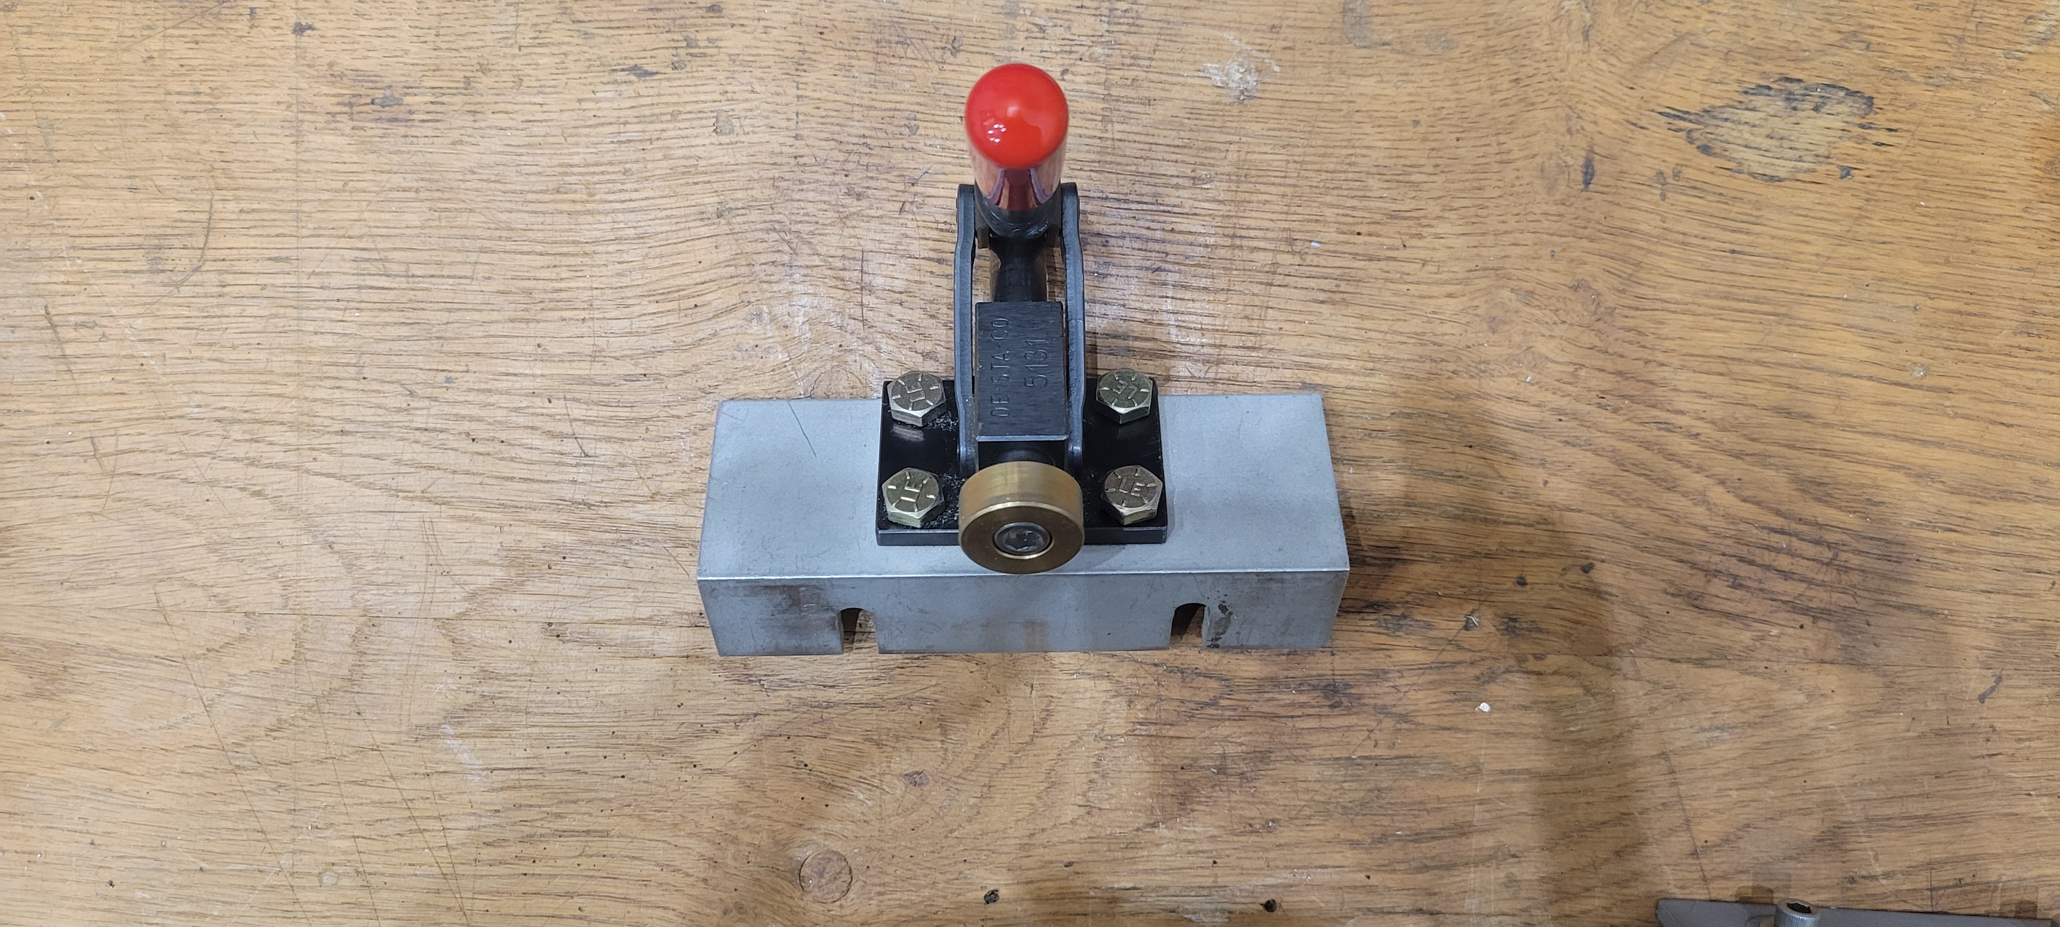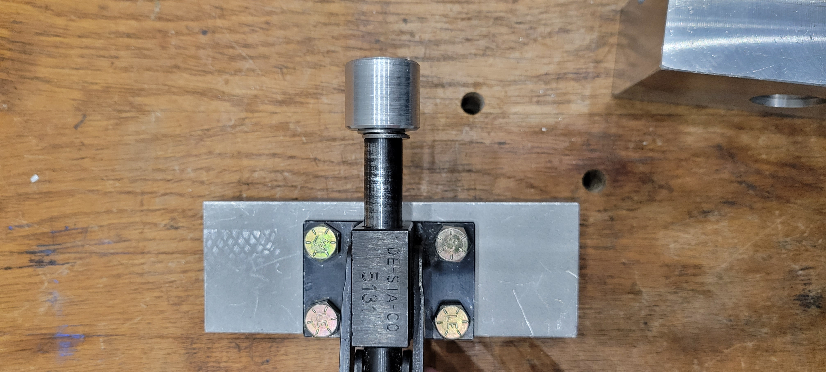

Profile clamp block- There are two different set of profile clamp block for thin and thick profile. The profile clamp should always be covered with the paper towel before clamping to avoid any scratches. To clamp the profile into place, the plunger is inserted and the red handle is puller

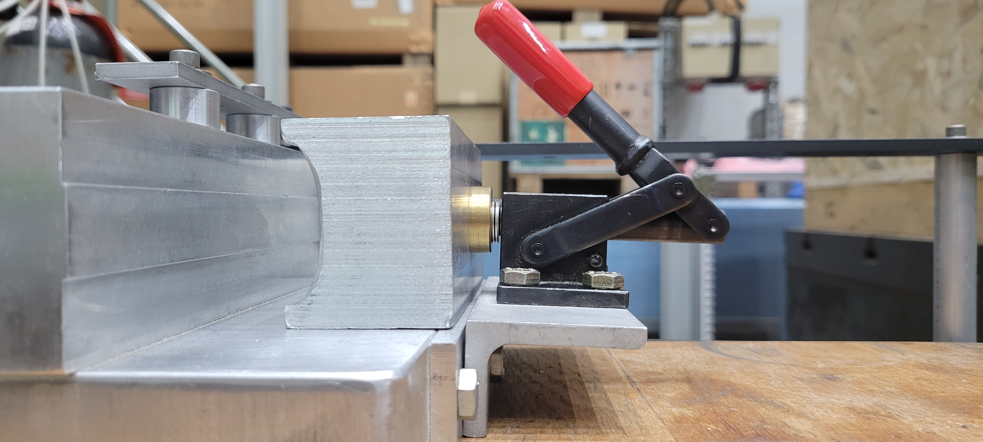

The profile clamp inserted into the clamp block.

Thick Profiles

Thin Profiles

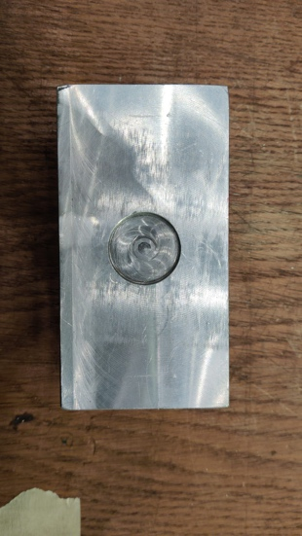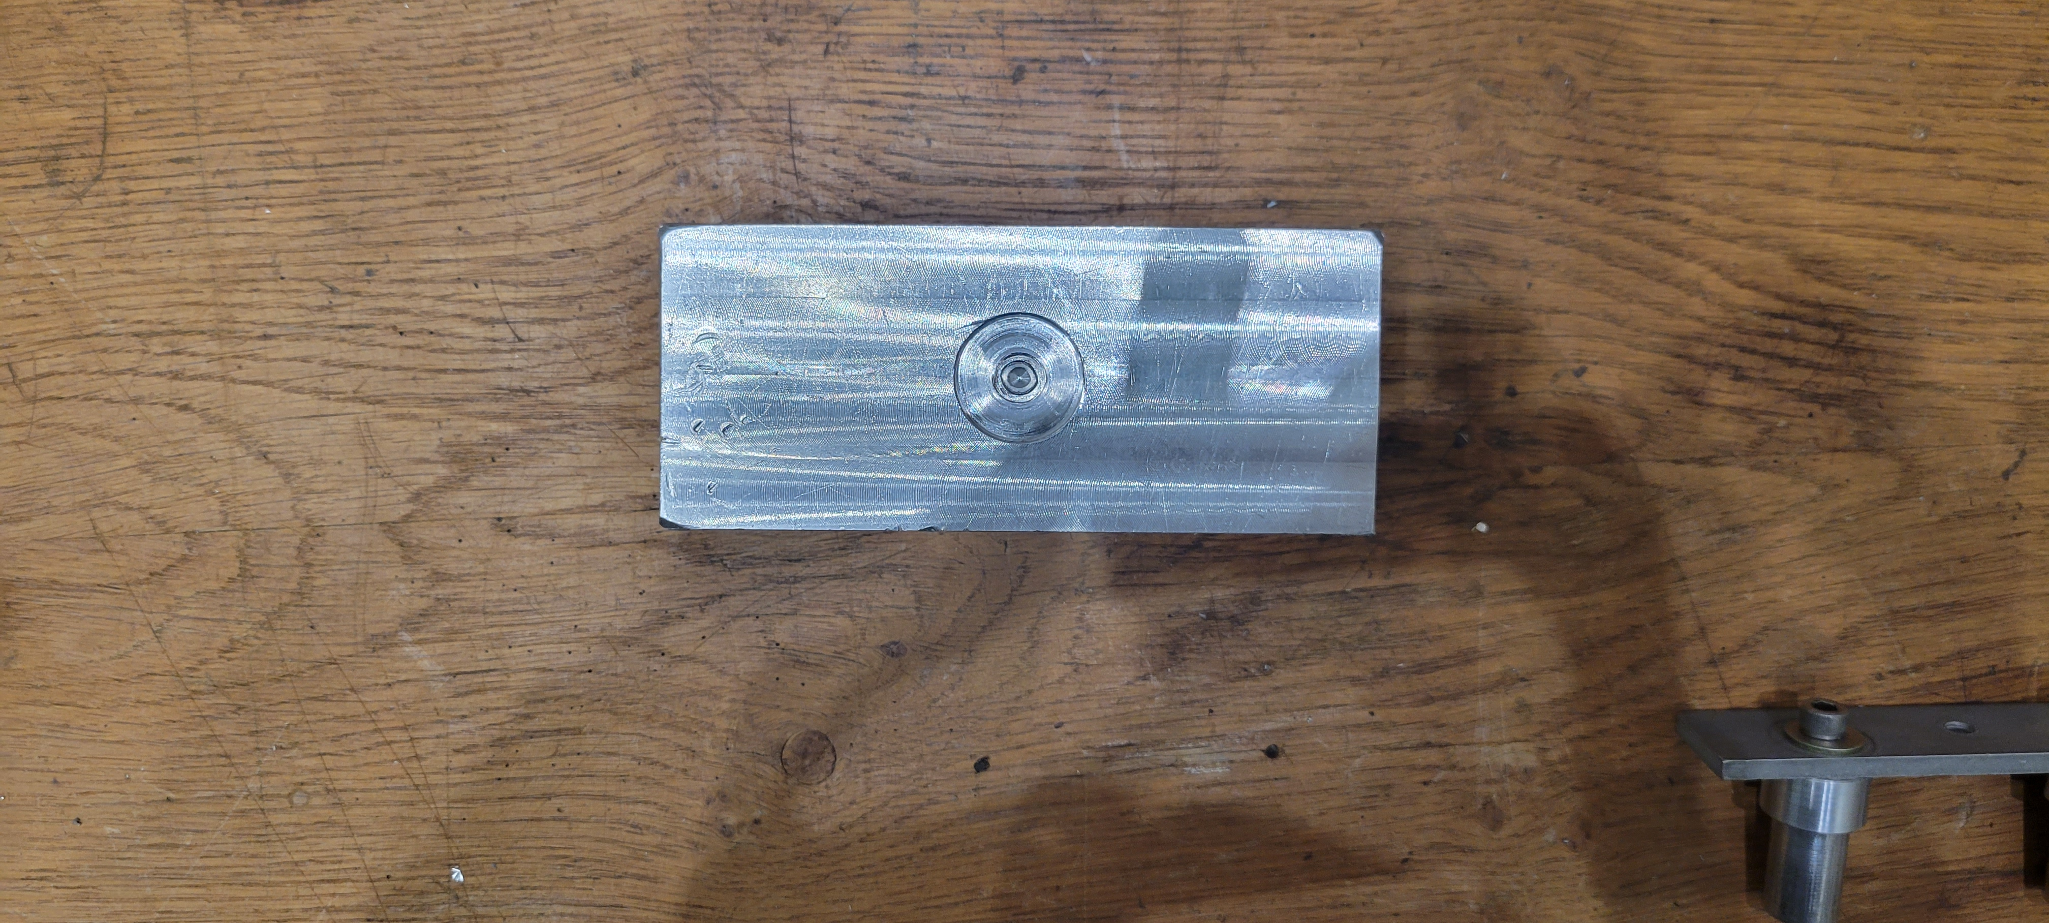

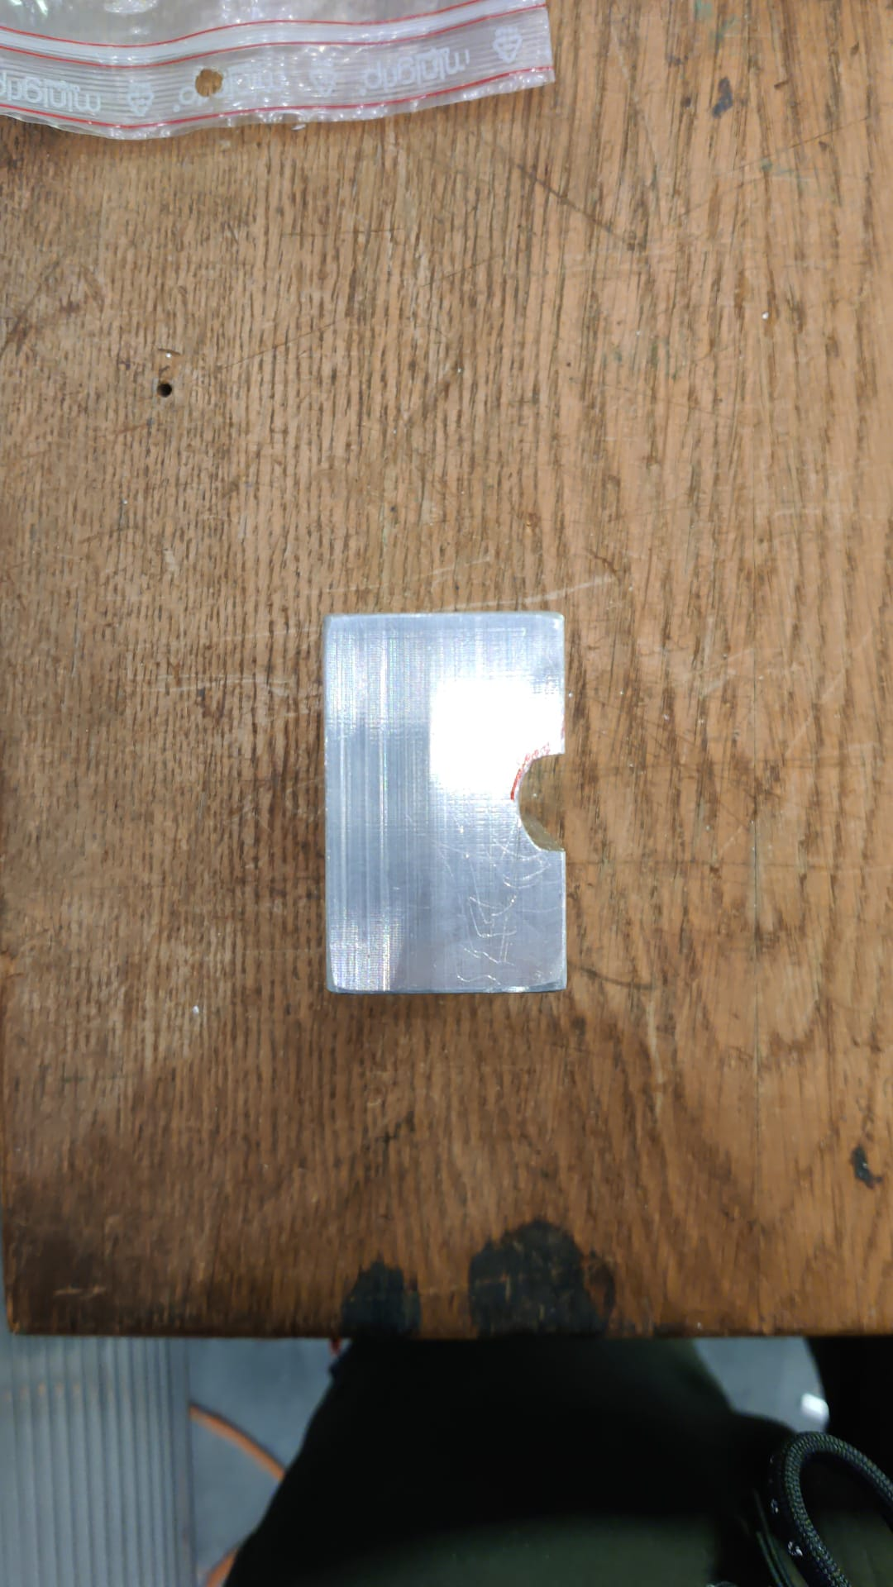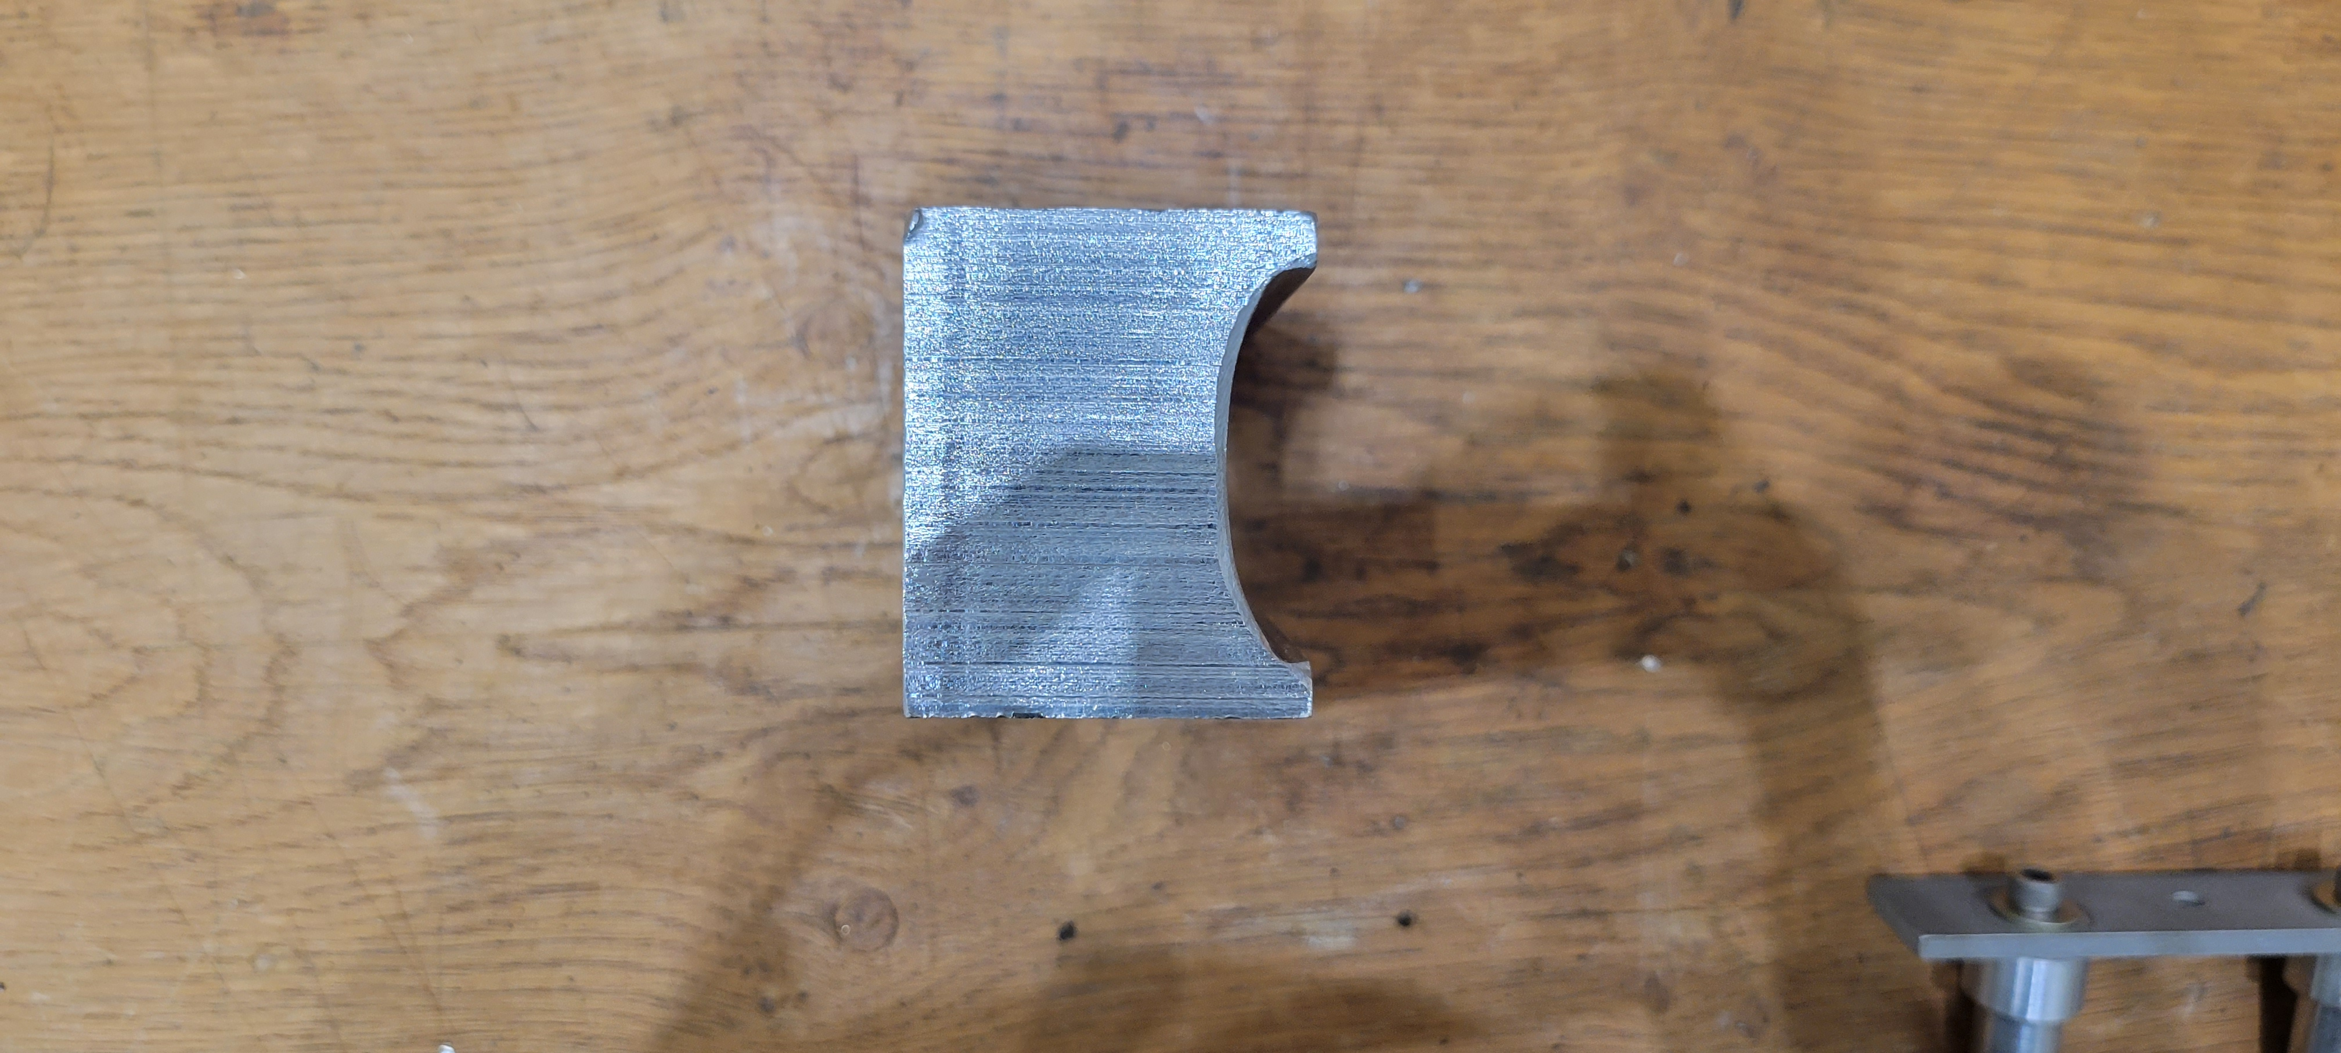

For the bending of the profile, you will need two blocks, one for each profile thick and thin. It is crucial to keep the Teflon block clean to avoid any dust or dirt streaks appearing on the profiles. There are two ways to insert a profile through the Teflon block. The preferred way is to slide it through by applying gentle force onto the profile while moving the block up and down. The other method involves placing the profile into position up against the profile length stop and inserting the Teflon block around the profile. Both methods can be used, but it is important to ensure that the profiles are inserted correctly to ensure proper construction.

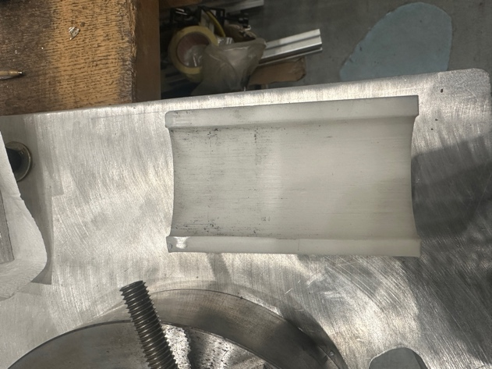

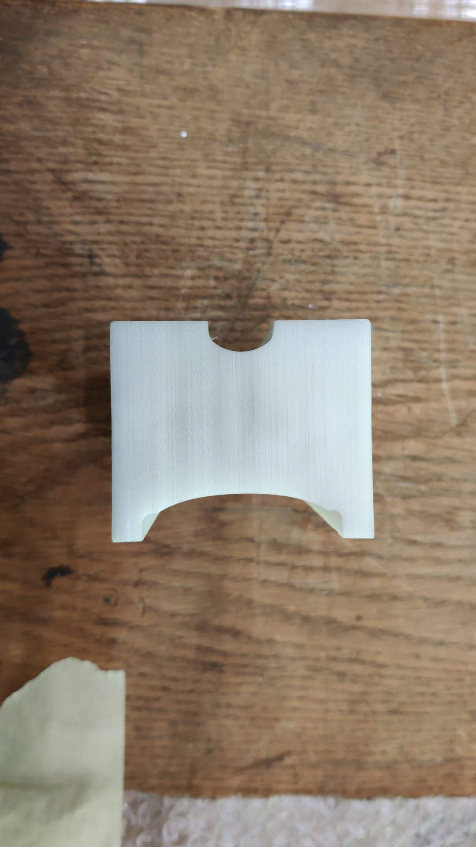

Thick Profiles

Thin Profiles

Profile length stop is used to set the fixed length for different profile to bend. For small productions, shims can be added to achieve the desired length. For instance, if you're working with thick bent profiles, you can use shims to adjust the length. However, for large productions, it's best to create a permanent stop to ensure consistency. To use the stopper, simply push the profile up against it to achieve the desired short length of bend. By using the stopper, you can ensure that your bends are accurate and consistent, which is essential for high-quality production.

NP02 Thick Profiles

NP02 Thin Profiles

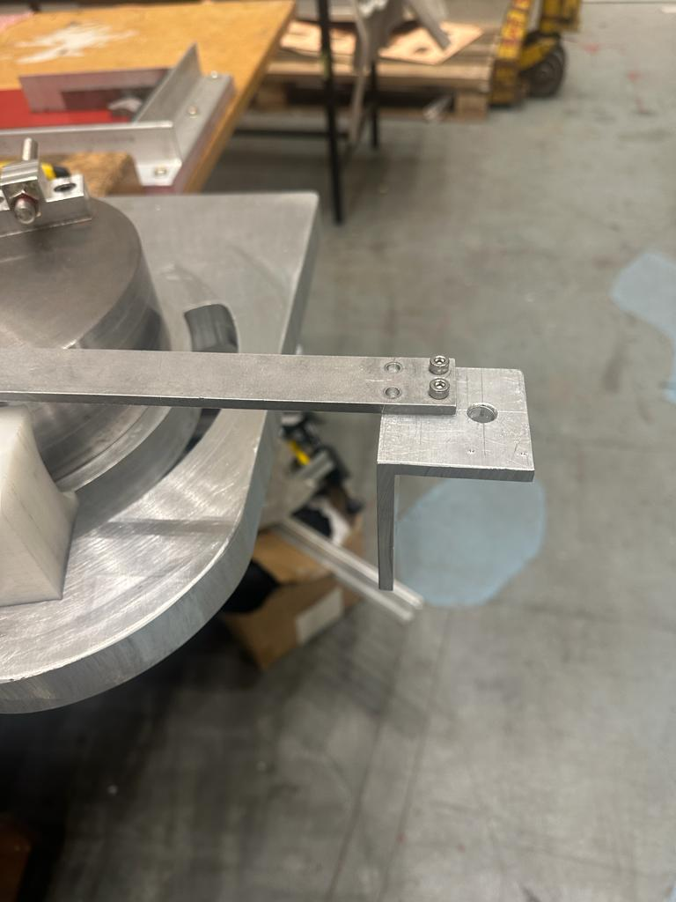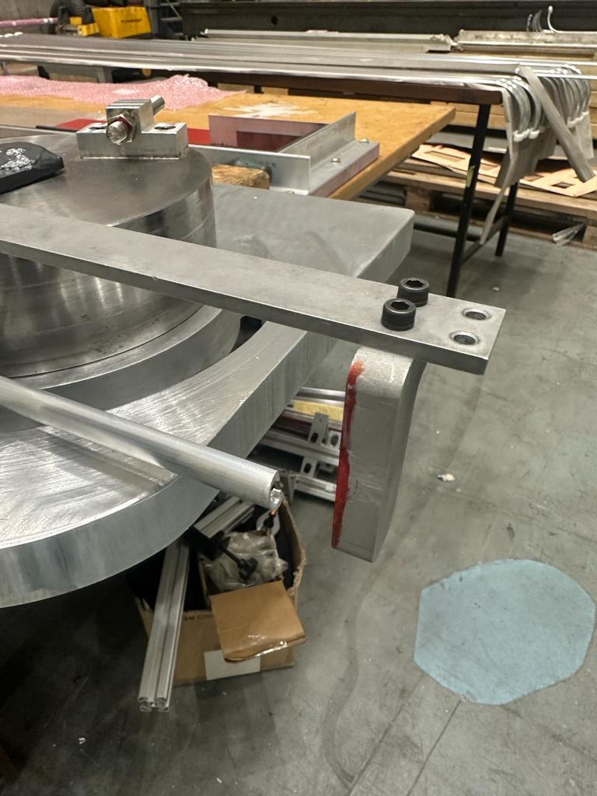

For the thin profile, there is no need to insert the rubber. However, for the proper bending the rubber need to be properly fitted inside the thick profile up to the 80% if its length. The rubber should be properly fitted, and all three pieces should be aligned together to get the perfect result.

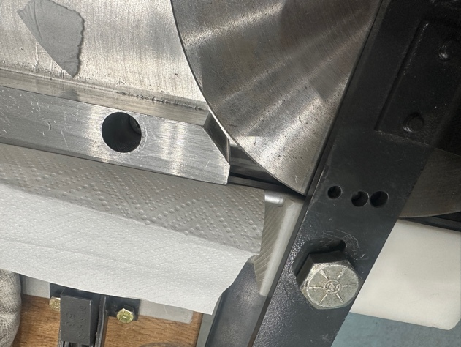

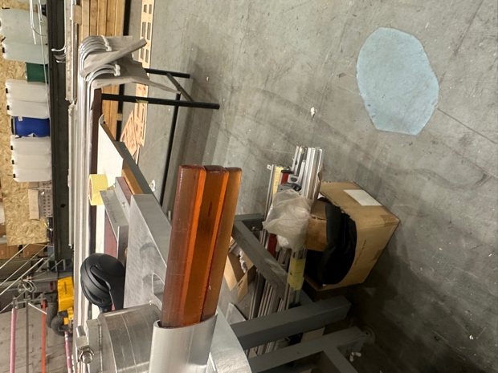

Proper bending of the thick and thin profile is QC using the QC bend tools, and a metal piece of 2mm is used as a tolerance for thick profile.

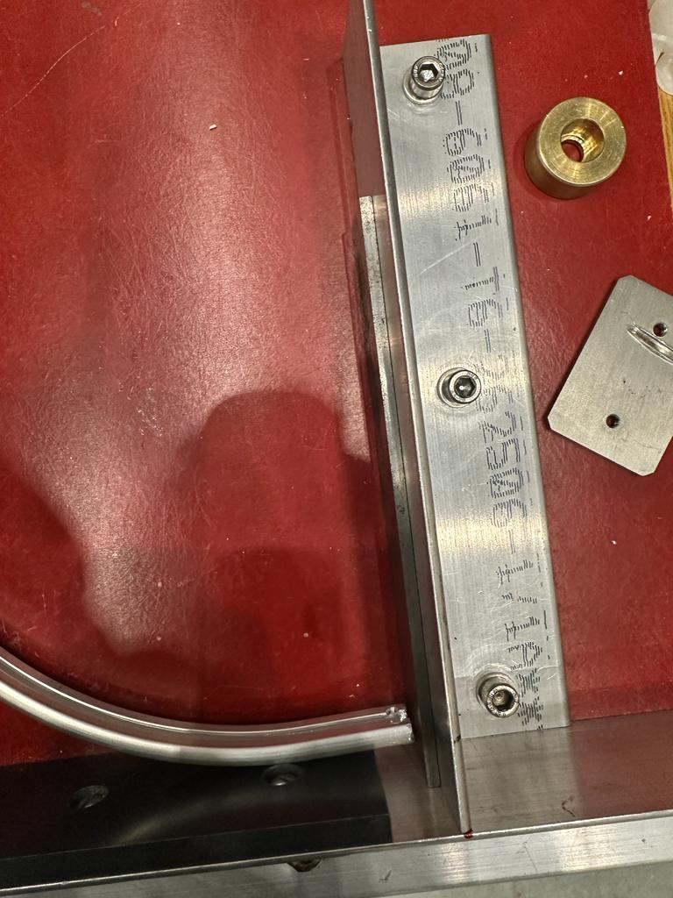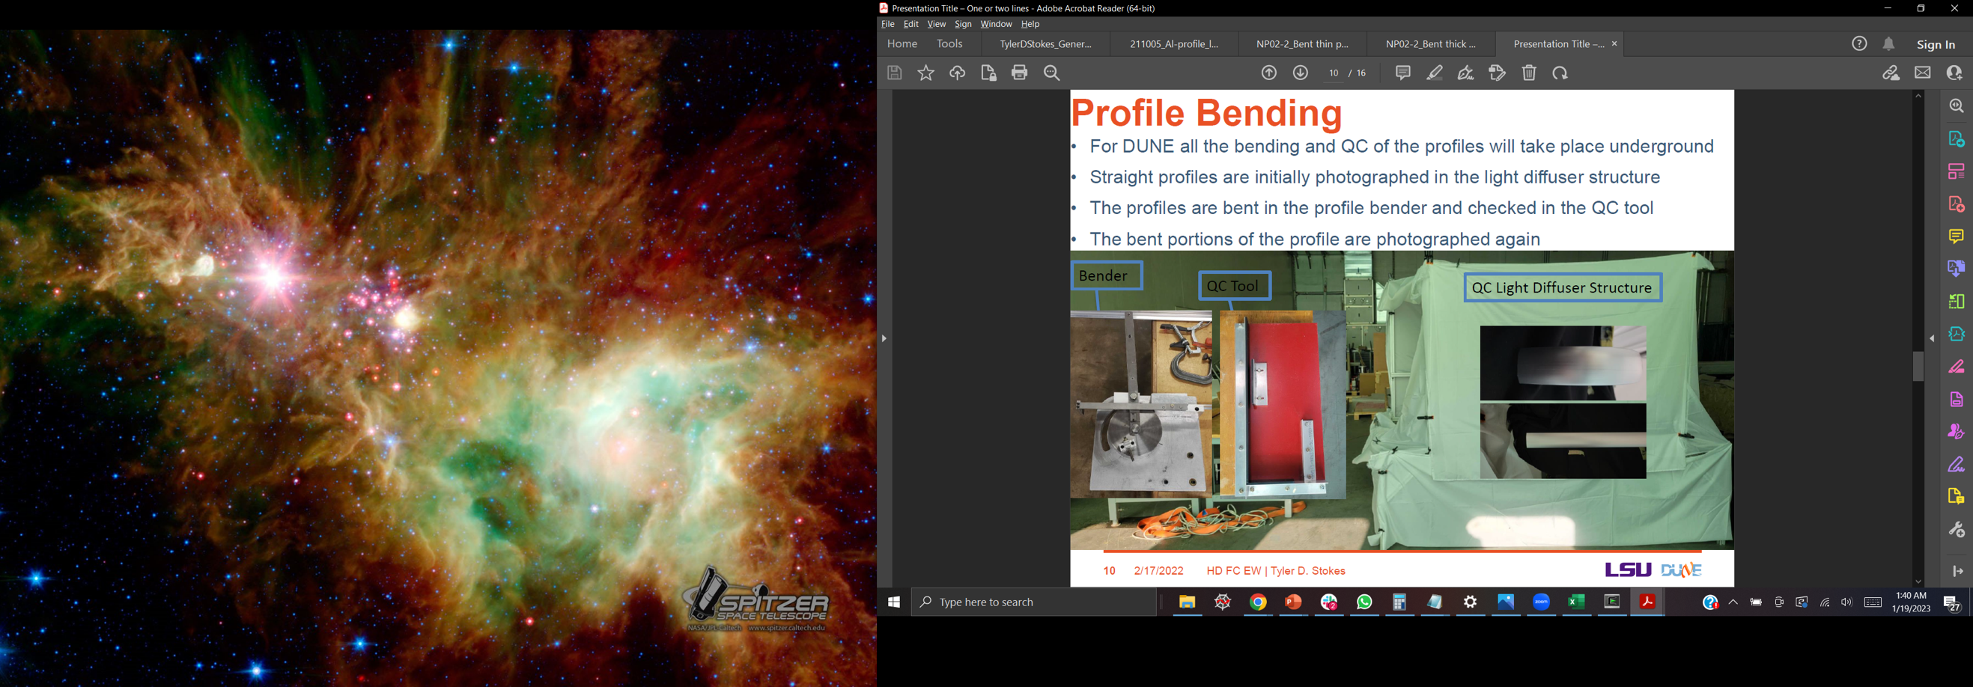

There might be slight deformation of the profiles is the bending is not done carefully. This will fail the QC of the profile, and it is checked by again smoothly running your bare hands in the through the bend side of the profile.

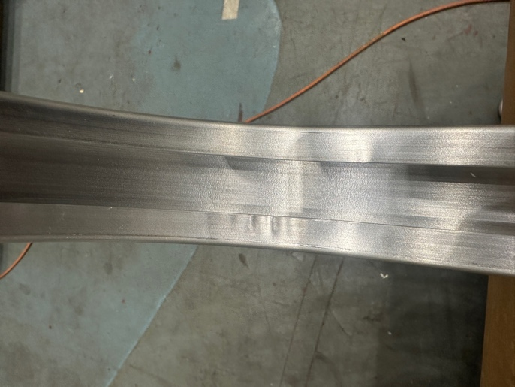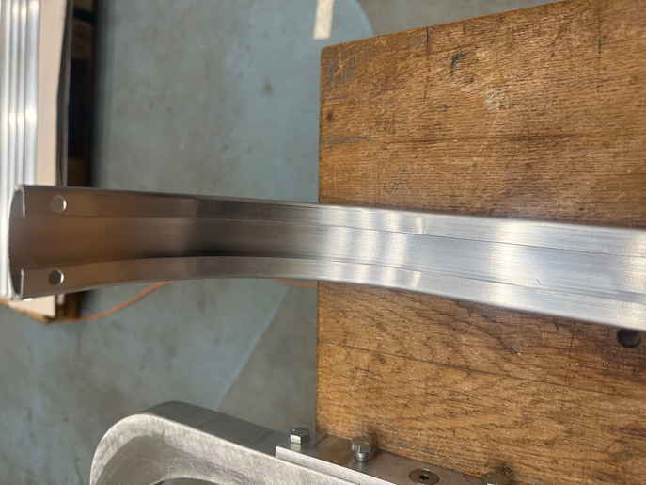

Finally, after all the QA/QC is completed, the thin and thick profile are needed to be properly packed using multiple layer of plastic bag to avoid any damage before shipping to the sites.

Conclusion

In conclusion, the successful construction of the proto-DUNE vertical drift heavily relies on the production of high-quality profiles. The four different types of profiles - thick straight, thin straight, thick bend, and thin bend profiles - play a crucial role in maintaining a uniform electric field inside the cryostat. To achieve this, the profiles must undergo several steps of quality checks, cutting, cleaning, and drilling to ensure a smooth surface, consistent length, and precision holes. The construction process for both the straight profiles and the bend profiles is outlined in detail in this documentation, highlighting the importance of each step. By following these procedures, we can guarantee the production of profiles that meet the necessary standards, resulting in the successful construction of the proto-DUNE vertical drift.

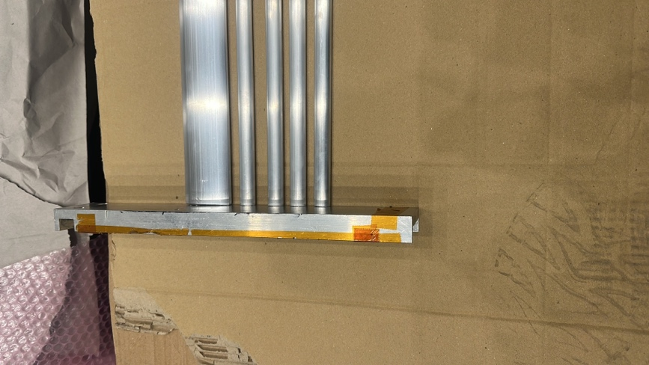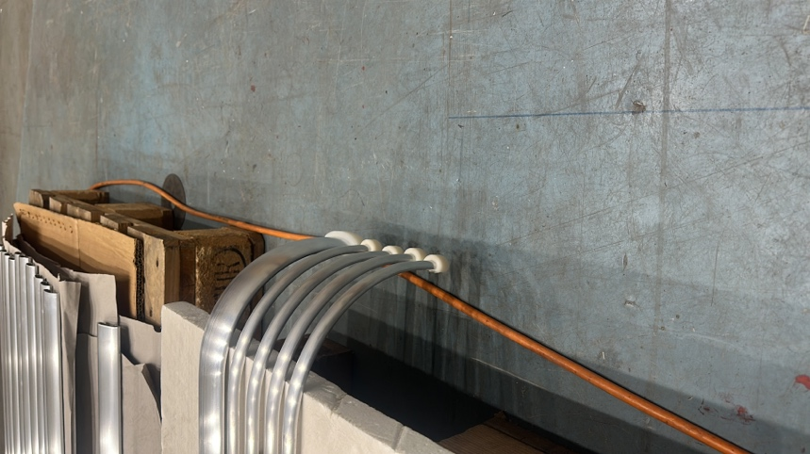Final Pictures of Profile

